HEEED MALAWI
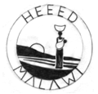
THE PEOPLE OF MALAWI
For first-time visitors to Malawi – there are many surprises in store: the country itself is endowed with spectacular landscapes – dominated by Lake Malawi, its rivers and the Rift Valley Escarpment. In addition, the people of Malawi – made up of different ethnic groups that are also found in neighboring countries, are known for their friendliness and rich oral traditions.
Below we have paraphrased some history from Fr. Boucher Chisale’s publication (Digging our Roots) and we would heartily recommend reading his book in its entirety. Father Boucher is, today, probably the foremost authority on the history, traditions and myths of Malawi. In addition, he is the moving spirit behind the creation of the Museum at Mua Mission with its magnificent displays and murals depicting the colourful history of Malawi – very well worth a visit: Kungoni Centre of Culture and Art http://www.kungoni.org

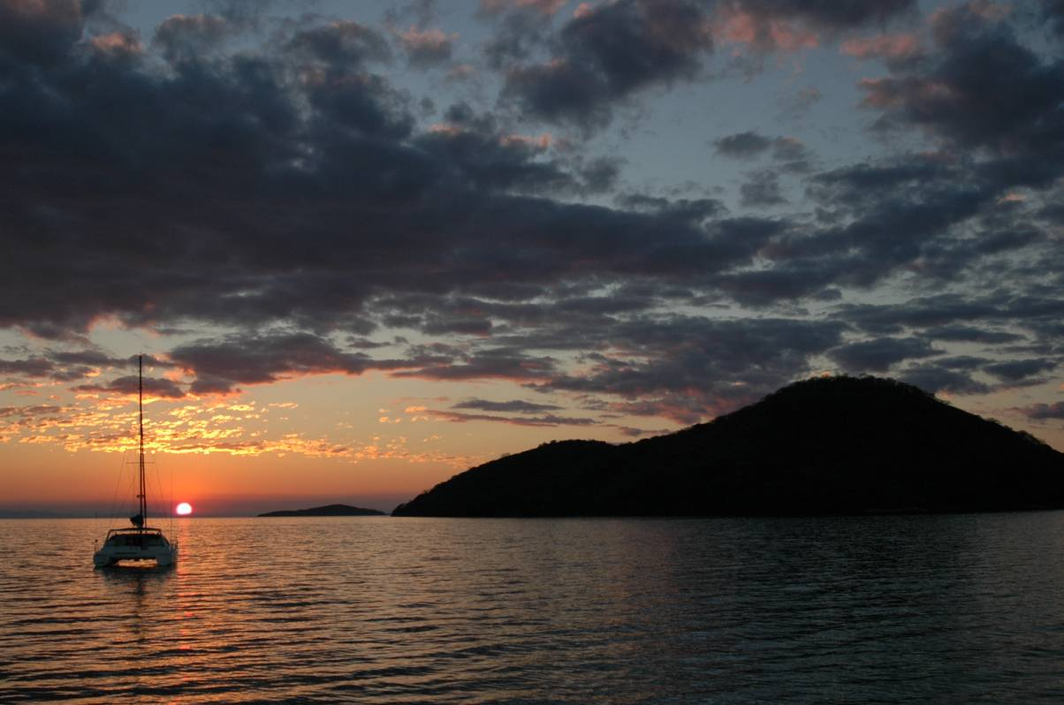

Sunset at Cape Maclear – Lake Malawi National Park

The Republic of Malawi, the country and the people we know today - with its magnificent Lake and varied topography, is the result of many migrations, encounters, conflicts and assimilations that stretch back over a thousand years. Beginning with the Akafulu hunter-gatherers and rock-dwelling artists, small groups of this Bantu tribe arrived in present-day Malawi circa 150 AD.
Further waves of Bantu-speaking tribes followed after 900 AD - the Banda - bringing iron-smelting skills and agricultural practices to Malawi. These tribes were eventually dominated by the Phiri in the 15th Century and present-day Chewa are descended from these two groups. Later, in the 16th Century, Mozambican Yao, with links to Swahili, Arab and Portuguese traders, began to move inland from the coast and settled on Lake Malawi, bringing Islam. They acted as intermediaries in a flourishing slave-trade to Zanzibar, as the Phiri domination began to wane and tribal rulers challenged their King (Karonga) in the middle of 17th Century.
Shifting alliances between small rival factions of Ngoni warriors (who arrived from South Africa in the 1820s) were then also challenged by Dr. Livingstone who arrived at Cape Maclear in 1859 – with the express purpose of abolishing the slave-trade in favour of honest trade. The Christian missionary movement, followed by British settlers – began to take root in Malawi and in l891, Malawi was declared a British Protectorate (Nyasaland). Blantyre and Zomba were the centres of commerce and administration until Malawi became independent in l964. (Ref. Digging our Roots, Fr. C. Boucher Chisale, 2002).

A BRIEF HISTORY OF HEEED - A MALAWIAN NGO
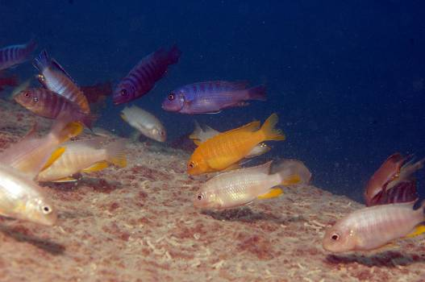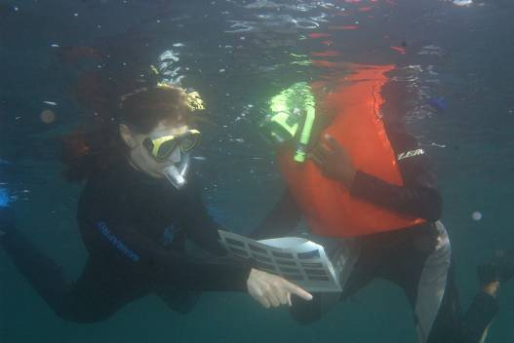

Unique cichlid fish of Lake Malawi National Park; using underwater slate to identify fish
The Lake Malawi Eco-region has been formally recognized by WWF (World Wide Fund for Nature) as one of the Global 200 regions with a sensitive ecosystem worthy of conservation. Lake Malawi National Park (LMNP) lies within the Lake Malawi Eco-region and was designated by United Nations in 1984 as a World Heritage Site - in recognition of the high fish species diversity and biological importance of its fauna.
The formally pristine Lake Malawi is severely over-fished, threatening to drive to extinction many endemic and endangered fish species. A dramatic increase in deforestation is another threat caused by the fuel needs of the rural communities lying within and around LMNP. With an increased population competing for diminishing natural resources, the task of conservation and environmental education has to include a comprehensive programme that addresses social issues related to the local population. Nowadays, the conservation of natural resources, health, environmental and economic development, are all inextricably intertwined.
WWF Finland founded and funded HEEED, as an NGO in 2004. In addition to promoting activities in the tourist sector, HEEED is also collaborating with various Ministerial Departments (Education, National Parks, Health and Gender) as well as Chembe Secondary and Primary Schools - particularly focused on health issues impacting on both communities and the environment.
HEEED is also the recipient of generous donations from various individuals and organizations (Skyband, Rotary, United Nations Development Programme, World Wide Fund for Nature (WWF), among others.

OVERALL HEEED OBJECTIVES

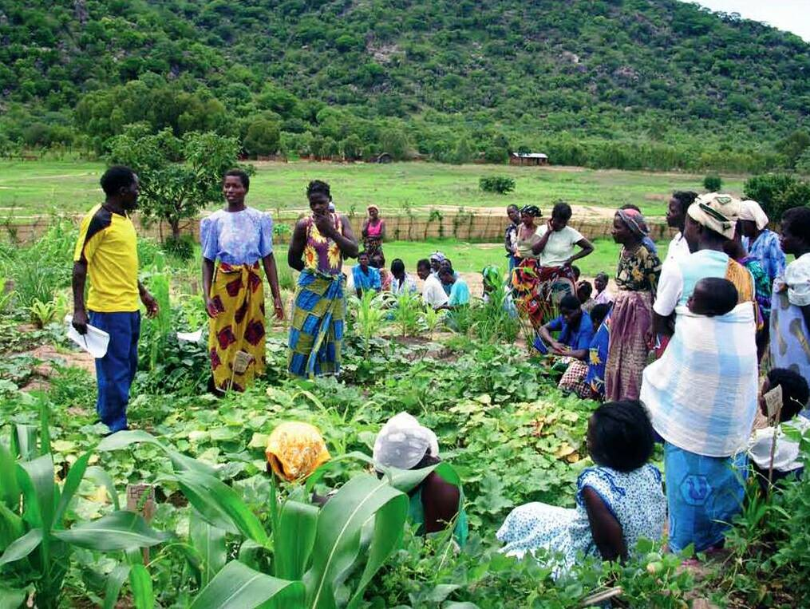

Horticulture class at Panda Garden

- Create alternative economic opportunities for local villagers in a sustainable fashion by:

- Developing a fuel briquette business, using waste vegetation;
- Promoting young artists to draw and to produce a variety of hand-made paper and handicraft products that include cards, books, bottle-top baskets, glass tumblers. Creative recycling is the hallmark of this HEEED Handicrafts Shop, that also provides an income to HEEED;
- Fostering an ecotourism industry focused upon the underwater wildlife that is unique to the region;
- Developing a fish management programme that now includes an aquaculture and agriculture programme adjacent to Lake Malawi National Park (Panda Garden).

- Develop an environmental education programme for the local community on the need to conserve, identify the flora and fauna of LMNP and understand the biology of their fishes by:

- Initiating a complete survey of the flora, fauna and fishes in LMNP and describing all presently scientifically unidentified species;
- Producing educational materials for both tourists and local communities, including posters and a guide book to the flora, fauna and fishes of LMNP;
- Organizing weekly after-dark evening shows at Panda Garden.

- Foster tree-planting of species indigenous to LMNP – in community wood-lots, school-yards and house-holds.

- Increase awareness of the bilharzia (schistosomiasis) disease, its connection with the snail-eating fishes and the need to conserve these biological control agents. This research is carried out from Cape Maclear – together with an evaluation on the effectiveness of a 100 m no fishing zone in the waters of Lake Malawi National Park and in front of the villages of Nankumba Peninsula. It determines if snail-feeding fishes and other economically important fishes increase in numbers within these important breeding grounds.

- Foster HIV/AIDS and nutrition awareness/training (particularly among children 6-12- years old) through art, drama and the use of wildlife cartoon characters in an educational booklet entitled “The Hiding Hyena”.

- Implement an Early Childhood Care Programme: since May 2013, 19 children, between the ages of 2-6, receive a daily meal -fortified likunipala porridge- 5 days a week; while also receiving basic English, singing and drawing lessons from 2 teachers.

- Develop co-operation between International and Malawi schools – connecting both teachers & students – to increase understanding of the different cultures and motivate Malawian students to take care of the environment in different ways. Children are the future stewards and need to be trained to observe their natural surroundings, understand their relationship with their environment and enable them from an early age to take care of a garden in their primary schools/homes.
Through this training, children are made aware of the Web of Life, the need for growing healthy food and how we all depend on our precious natural resources. Children will also understand why the conservation of Malawi’s National Parks is important for their future well-being. Children will also learn to understand the main concepts behind the Malawi National Anthem – in particular the need to “eliminate poverty, disease and envy”. This needs to be addressed at all educational levels.

